EMERGENCY ACTION PLAN
TEXAS ELKS CAMP ON TEXOMA
2026

EMERGENCY ACTION PLAN
Table of Contents
- Purpose
- Scope
- Prevention
- Emergency Response on Site
- Training
- Accountability
- Communication
- Conflicts and Deviation
- Plan Distribution
- Revision and Plan Maintenance
- References
- Glossary
Appendices
  - Camp Information
    - Flood Plain Map
    - Base Camp Flood Plain
    - Whole Camp Borders and Flood Plain
    - Muster Zones
  - Contacts
  - Acronyms and Abbreviations
  - Evacuation and Muster Zones
  - Shelter in Place
  - Lost Person Procedure
  - Fire Emergency Procedure
  - Flooding Emergency Procedure
  - Severe Weather, Thunderstorms, and Tornadoes
  - Severe Injury, Accident, Illness, or Death Procedures
  - Epidemic Plan
  - Aquatic Emergency Procedure
  - Stranger or Unauthorized Person on Camp
  - Active Shooter Procedure
  - Animal Encounters
  - Transportation Emergency Procedure
- PURPOSE
  - The primary purpose of the Emergency Action Plan (EAP) is to ensure the safety of Texas Elks Camp on Texoma’s (TECOT) guests, visitors, and staff. With over six hundred acres of forested land sharing five miles of waterfront on Lake Texoma in a resort area, the camp has multiple sources of potential threat or emergency. This EAP seeks to recognize potential emergencies and focuses on preventing, mitigating, and resolving emergency incidents through an established response framework.
  - The secondary purpose of the EAP is to comply with the 2026 Texas Youth CAMPER Act, the Heaven’s 27 Camp Safety Act and the Texas Health and Safety Code 141.0091.

- SCOPE
  - This EAP applies to all TECOT staff, volunteers, visitors, and campers who have emergency response roles and responsibilities. They will be expected to know and understand the EAP and their specific roles and responsibilities during an emergency and faithfully execute the duties assigned to them.
  - This EAP applies to all TECOT staff, volunteers, visitors, and campers on site with no specific assigned role or responsibilities during an emergency. They will be expected to follow commands of those in authority during the emergency incident and diligently work to accomplish commands given to them.
  - TECOT considers all guests, campers, and/or visitors to be Rental Groups. If the EAP is activated during their stay or visit to camp, all Rental Groups are expected to follow the instructions passed on to them. At no time will a member of a Rental Group coordinate or lead an emergency incident response on site once the EAP is activated.

- PREVENTION
  - TECOT Staff will consistently monitor the National Weather Service (NWS) forecasts daily and stay abreast of the current and next-day forecasts, as well as the long-term forecast to make sound decisions about facility use and site safety. The Camp Director and EPC will monitor daily and long-term forecasts when groups are on site. While certain staff are assigned the responsibility, all staff radios (10 in total) can monitor the National Weather Service frequency. Any staff member who monitors or receives pertinent severe weather information through weather radios, social media, or phone apps will immediately relay that information to the Camp Director or senior leadership staff who will make the decision about enacting the EAP and sounding the EAS.
  - The camp maintains 4 NWS weather radios. They are located in the main office, both on-site staff residences, and the Camp Director’s private residence off-site. They are tested weekly and maintained in working order by the Camp Director.
  - During active weather events, the Camp Director, EPC, and staff user group host (TECOT staff assigned by TECOT to each user group) on staff will monitor the NWS weather alert radio for real-time updates to forecasts and the issuance of watches and warnings. Each staff residence on site (CEO and Program Director) and the main office all have weather radios. The Camp Director and ERC have weather radios at their residences off site. While certain staff are assigned the responsibility, all staff radios (10 in total) can monitor the National Weather Service frequency. Any staff member who monitors or receives pertinent severe weather information through weather radios, social media, or phone apps will immediately relay that information to the Camp Director or senior leadership staff who will make the decision about enacting the EAP and sounding the EAS.
  - During periods of elevated risk, the same staff will monitor additional relevant sources, such as the Grayson County Sheriff’s Office social media, Texas Forest Service Fire Weather Maps, US Army Corp of Engineers Lake Texoma lake level site, Grayson County Health Department postings, or scanning local emergency radio frequencies. The main office has the ability to monitor county emergency dispatch channels as well as the EPC.
  - Annual letters of operation will be sent to Locust Volunteer Fire Department, Preston Emergency Medical Services, Grayson County Sherriff’s Office, and Texoma Medical Center informing them of our expected operation that year, a means to access the property in case of emergency, and points of contact.
  - The EAP will be reviewed annually and sent in its entirety to the Texas State Department of State Health Services and Grayson County Office of Emergency Management. Any changes to the EAP will be sent to DSHS for approval and then forwarded to OEM.
  - Due to the nature of operation of the camp and limited staff residing on site, there may be times there are no staff on site, or staff may be on-site but off duty. During those periods, guests will be advised of the situation and given contact information for an off-site staff member who is the emergency point of contact.
  - TECOT serves only rental groups, which are, as defined by the American Camping Association (ACA), an organized third-party group, camp, or program that rents or leases a camp's facilities to operate its own independent camping programs or retreats. While a rental group may use the camp's premises and some of its services (such as food services or lifeguards), the primary responsibility for the well-being, staffing, and programming remains with the group and its independent leaders. Because of this, TECOT advises all groups to bring resources to make sure their stay is safe, including but not limited to background checked adults to meet specific adult to child ratios, medically trained adults and first aid supplies, copies of lifeguard certifications (for aquatic activities), and emergency transportation.
  - TECOT is inspected by numerous agencies annually for mandatory and voluntary compliance. These agencies include, but are not limited to, The United States Army Corp of Engineers for site safety and federal law compliance, The Texas Department of State Health Services for compliance with state youth camp laws, the Grayson County Health Department for sanitation and kitchen health code inspections, and the American Camp Association for voluntary compliance with standards overseeing administration, site, and program standards. Compliance with inspections is a primary prevention tool for TECOT.

- EMERGENCY RESPONSE ON SITE
  - The Emergency Response Framework (ERF) on site will resemble a standard, structured hierarchy of an incident leader that oversees the response and assigns responsibilities down the chain, as necessary. The framework may consist of a single individual or many individuals depending on the scope and needs of the emergency incident. The ERF is designed to be scalable to meet the needs of the emergency incident while not utilizing superfluous resources.
  - The Emergency Response Team (ERT) includes any individuals whose role has changed for the emergency incident. Individuals who have been given responsibilities exclusive to the incident make up the ERT. Individuals who are aware of the emergency incident yet continue their normal daily assignments are not considered part of the ERT.
  - Response Priorities follow the accepted norm of emergency response. These priorities, in order, are Life Safety, Incident Stabilization, Property Conservation, and Operational Continuity.
    - Life Safety includes pre-emptive moves to protect campers, guests, volunteers, and staff from harm. Locating and treating injured people is included in this step, as well as accounting for all people on camp.
    - Incident Stabilization begins with calling 911 and beginning professional emergency response. Preventing the spread of the incident into other areas or introducing secondary hazards or incidents is part of incident stabilization. Trying to contain or control the emergency to prevent spreading to other areas falls under incident stabilization.
    - Property Protection refers to reducing the environmental impact of emergency incidents, as well as protecting camp resources such as buildings and equipment.
    - Operational Continuity refers to resuming normal activities as soon as possible. This may mean using modified schedules or events until the emergency incident is over. This response priority can last well after the emergency incident is over.
  - Roles and responsibilities: An emergency incident on site will vary based on the type of emergency. There will always be a designated leader, Titled the Incident Coordinator (IC) for the emergency on site. Ideally the role will fall to the Chief Executive Officer Steve Weatherly, Camp Director Sandi Cresswell, or Emergency Preparedness Coordinator Josh Velten. In their absence, a program director or facilities director may assume that role.

    - Other leadership roles that may be assigned by the (IC) include an Accountability Coordinator (AC), Medical Coordinator (MC), Transportation Coordinator (TC), or Communication Coordinator (CC). Anyone who fills these roles may need to work with the designated rental group leader to make sure their areas of responsibilities are addressed.
    - Support positions include any TECOT representative tasked with helping to alert, gather, or care for the campers and guests at camp.
    - Rental Groups may provide support positions as well under the direction of the IC. Rental group representatives may support TECOT operations to achieve incident goals. During any activation of the EAP, rental groups, including rental group leaders, will work under the IC to achieve operational goals. At no time will a guest assume authority or control over a declared emergency at camp.

- TRAINING
  - Training and Exercises: TECOT will conduct EAP training for all staff annually as required by law. All campers will receive orientation to the site and facilities to include emergency procedures. Exercises will be conducted periodically. All training, orientations, and exercises will be documented and maintained as required by law.
  - Annual Staff Training: TECOT staff will receive annual training every spring that covers:
    - Overall Review of the Camp EAP
    - What Constitutes an EAP Activation
    - Roles and Responsibilities During an EAP Activation
    - Communication Process During an Emergency
    - Difference Between Shelter in Place, Muster Points, and Evacuation
    - Accountability Procedures and Responsibilities
    - Response Action Scenarios During EAP Activation
The training will be conducted in person by the EPC, and completion records will be maintained by the Camp Director and EPC. Completion is verified by attendance roster.
  - Camper Orientation and Training: A Camper Safety Orientation (CSO) must occur, by law, within the first 48 hours on camp. TECOT aims to hold the CSO at the first meal of the stay or at the first whole camp activity where the entire group is present. The CSO is delivered by the Camp Director, Program Director, or User Group Host (Camp Staff) must include:
    - Identification of Camp Boundaries
    - Identification of Camp Hazards
    - Orientation to Camp’s Emergency Alert System (EAS)
    - Actions to Take During an Emergency
    - Camper Behavior and Expectations During an Emergency
The Camper Safety Orientation will be delivered in an age and developmentally appropriate manner and any training during the orientation will also be done at a developmentally appropriate level for the campers. TECOT will work with the user group leader to ensure that special needs populations in the group receive appropriate instruction to their level of comprehension. The Camp Director and Program Director(s) will annually review the CSO to ensure accuracy and relativity of the content to TECOT guests and users.
  - Rental Group Training: At times, TECOT staff may be asked by a rental group to provide additional training or safety information, including monitoring drills or exercises, skills check-offs, or third-party safety instruction-an example would be lifeguard instructors. All safety and training related group instruction should be documented, including the date, group, and what training or observation was performed.

- ACCOUNTABILITY: The accountability process when the EAP is enacted is a shared duty but the responsibility of the appointed Accountability Coordinator. When appointed by IC, the job of the AC is to coordinate the health, status, and location of every camper and staff member during an emergency incident. This may be done in partnership with the rental group leader or their representative, especially for larger groups where being paired with someone familiar with the campers is beneficial. The IC may appoint other staff who report to the AC to aid in situations where the campers may be in several locations at once.
The process of accounting for campers and staff can be complex based on the type of incident and the number of people involved. Accountability should be taken on the activation of the EAP. The process needs to be recorded either by writing it down or tracking it on an electronic device. The record will include the date and time, the location (be specific), and any campers or staff who are not accounted for. A new accountability report needs to be taken anytime the group moves location, is split or merged with other groups, or a potential missing person is realized and reported to the AC. While the EAP is active, an accountability report should be taken no more than an hour from the previous one.

- COMMUNICATION: Communication occurs prior to, during, and following an emergency. Communication is a very important key in successfully navigating an emergency. The EAP has divided communication into five areas of operation.
  - Internal Communication: Internal Communication is communication that occurs between TECOT staff, directors, and volunteers. The staff daily interact, communicate, and mitigate minor incidents that do not require activation of the EAP. When there is an emergency that requires the activation of the EAP, staff should report it to the most senior ranking staff person on site (Executive Director → Camp Director → Emergency Preparedness Coordinator → Program Director). The report should be made in the quickest route possible (radio, cell phone, in person) and needs to include who is reporting the emergency, the location of the incident, the type of emergency, and any injuries or realized hazards. Once the senior staff has received the report of an emergency, that person becomes the Incident Coordinator (IC) and will assess the situation and activate the appropriate emergency procedures. Roles may be added by the IC based on the scope of the incident. Communication between the staff will be carried out by the primary (2-way radio) communication system and by back-up systems (cell phones, public address system) as needed. Staff will acknowledge and carry out assigned roles and responsibilities according to the EAP. Updated information, new injuries or hazards, and accountability concerns will be communicated to the IC. Other communication should be kept to a minimum to allow for the transmission of emergency related priorities.
  - Guest/Camper Communication: Once the EAP is activated, camp staff will relay clear, calm, and age-appropriate instructions to the guests/campers on site. The first round of communication will more than likely occur using the camp-wide paging system, the Emergency Alert System (EAS). This system will reach all sleeping, meeting, and dining spaces simultaneously and broadcast information about the emergency and the directions for campers and guests to follow. All groups will have adult leadership present and they will be the main point of contact for instructions; however, care should be given to avoid panic or confusion of younger campers. While the adults with the group are the main points of contact, they will not be permitted to vary from directions given or try and communicate their own plans contrary to the EAP. TECOT Staff that are with groups will work with them to ensure accountability and instruction comprehension. Activation of the EAP overnight or weekends when fewer TECOT staff are present will be modified to meet the situation. Guest leadership may be given radios to aid in communication as needed while TECOT resources are expanded. TECOT may call in additional staff after hours as needed to mitigate an emergency. It is up to the IC to weigh the factors involved, such as the nature of the emergency, age of the group, and response times, and decide if additional staff resources are needed.
  - Emergency Assistance refers to communication with First Responders, including the initial call to 911. Because of TECOT’s location on the lake and so close to Oklahoma, occasionally 911 calls go to Bryan County, Oklahoma. Make sure the 911 dispatcher is for Grayson County, Texas. If they are not, they will transfer the call to Grayson County. Mentioning this right away to the dispatcher can save minutes later in the call. Whomever is designated to call 911 must be sure to have as much up to date information as possible and be prepared to stay on the line with 911 telecommunicators until help arrives on site. Once First Responders arrive on scene, they will be directed to the emergency scene and the TECOT IC needs to be notified. At this point, the IC will remain with First Responders and be the primary communication link between the camp and emergency responders.
  - Media will show up shortly after any major incident occurs. Media includes news agencies (film and print), photographers, and social media representatives. IC will establish an area for media to gather, and all media will be directed to that spot. IC may rely on law enforcement to control the media presence on a larger incident. TECOT’s official representative will be the IC. No other TECOT staff or volunteers will engage the media without specific consent or direction of the IC. User group representatives do not fall under TECOT’s media restrictions and may speak with media representing their own organizations.
  - Families and Local Residents who show up on scene need to be directed off the property until the incident is over. Law enforcement may be called/used for this if necessary. User groups renting the camp are responsible for all contact with their camper’s parents and guardians. TECOT does not require nor maintain lists of attendees for user groups who rent the camp. It will be the responsibility of the user group leader to maintain contact with the groups home organization and all parents, guardians, and family members of their group members. Any calls to the camp office regarding user group attendees will be forwarded to the user group leader. TECOT may provide resources or staff to aid in the process if requested by the user group leader.

- CONFLICTS AND DEVIATIONS
  - The plan will be reviewed and revised annually. During the time of revision, input is welcome and any modifications that will improve or update the EAP will be considered and addressed.
  - During times of emergency, it is understood that the dynamics of every incident may differ. Deviating from the EAP during times of activation can be authorized by the IC or EPC and should be documented for review after the incident is over.

- PLAN DISTRIBUTION
  - The EAP will be available by law to users of the camp and on the website. Also as required by law, the plan will be submitted to DSHS for review annually and submitted to Grayson County Office of Emergency Management after DSHS approval.
  - The EAP by law must be available to all parents and guardians of user group campers and prospective user group campers who may be visiting TECOT in the future. The EAP is available at www.elkscamptexoma.com under the “Parent Resources” tab.
  - User groups that meet the Texas DSHS Youth Camp requirement will be notified of the need to get additional reporting from parents and guardians of their youth campers. A parent or guardian of each youth camper must sign the authorization and acknowledgement that they have been provided the EAP and that part of TECOT’s property exists in a floodplain. These forms will be collected by the user group leader prior to arrival or at camper drop-off and turned into TECOT staff upon arrival at the camp or completion of on-camp check-in. The forms will be available for download from the “Parent Resources” tab or available in paper form to group leaders on site. TECOT is required by law to collect and maintain these records.
  - The following chart reflects the distribution and time frames necessary for the EAP to meet all legal requirements.
Group | Timeframe | Outcome
Camp Staff | Annual training and after major revisions | Documented acknowledgement of training and receipt of EAP
User Groups | Prior to first day of camp | Made available via website and link in user group contract
Texas Department of State Health Services (DSHS) | Submitted annually by March 31 | Acceptance by DSHS prior to first day of camp
Grayson County OEM | Submitted within 10 days of approval by DSHS | Receipt of EAP confirmed in writing
General Public | Anytime | Website

- REVISION AND PLAN MAINTENANCE
The EAP will be evaluated at the end of every camping season (December-January) and will be revised for the upcoming camp season. Input from staff, reviews from user groups, and lessons learned during EAP activation will be considered as the EAP is prepared for the next season. The process will be under the supervision of the TECOT EPC and will also consider new technologies and camp features that may influence or affect the EAP. DSHS must be notified anytime the plan is revised, with a copy sent to OEM after DSHS approval. Revision notes will be kept in the back of the TECOT hard copy of the EAP.
- REFERENCES
•Heaven’s 27 Safety Act Texas SB 1 (2025)
•Youth Camp Alert, Mitigation, Preparedness, and Emergency Response (Youth CAMPER) Act HB 1 (2025)
•Texas Health and Safety Code §141.0091
•Texas Government Code §418.1015

- GLOSSARY
Accountability: Confirming and documenting the location or status of all campers, guests, visitors, and staff during and after an activation of the EAP.
Activation: Point in time when the EAP becomes active to mitigate a declared emergency.
All Clear: Formal Notification by the IC or authorities that the threat has ended and normal operations will resume.
Camp Safety Orientation: Process by which all guests and users of TECOT receive valuable information about the site, facilities, and emergency actions and responsibilities.
Camper-generic term used for any guest, adult or youth, registered to be onsite at TECOT.
Emergency: An event requiring immediate action to protect life, health, or property.
Emergency Action Plan: The all-hazards plan put in place to govern actions during all emergencies on TECOT grounds or affecting TECOT operations.
Emergency Alert System-system utilized by the camp to alert occupants of an emergency which includes camp paging system, beacons, radios, phones, and voice communication to alert all staff and campers simultaneously, including hearing impaired guests. The paging system does not rely on internet and can be operated remotely by multiple staff. The primary responsibility falls on the Director to operate it during the day and the on-site Program Director after hours.
Emergency Preparedness Coordinator- DSHS created role required for each youth camp in the state. TECOT requires the EPC to oversee all emergency preparedness for the site, users, and programs. This is done by directly creating and maintaining DSHS mandated documents and procedures, training staff annually on the EAP, quarterly paging system tests, reviewing and modifying camp documents and procedures to align with new safety and operating guidelines, conducting annual reviews of safety and preparedness policies and procedures, and actively monitoring potential impacts to TECOT facilities, staff, and users. During activation of the EAP, the EPC, if not on site, will be in contact with IC and serve as an advisor on decisions and response.
Epidemic: Widespread occurrence of a disease affecting large populations or regions.
Evacuation: Organized relocation or removal of people from an unsafe area to a designated safe location using planned routes.
Exercise: Training or drill to practice response roles and activities.
First Responders: Refers to any outside fire, EMS, or law enforcement personnel arriving at TECOT during an emergency.
Lockdown: Protective action involving securing occupants in place, limiting visibility and movement, and restricting access.
Medical Emergency: Condition requiring immediate medical assessment and possible EMS activation.
Minor Incident: Refers to an incident requiring attention of the staff but not to the point of activating the EAP.
Mitigation: the act of reducing the severity and seriousness of an incident.
Muster Zone: Designated area where people are moved to allow for accountability, potential evacuation, and safe gathering.
Outbreak: Increased cases of an illness above expected levels within a group
Paging System: Refers to the camp wide paging system that alerts all sleeping, meeting, and dining areas to an emergency simultaneously.
Prevention: Steps taken prior to an emergency to limit the impact of the event
Rental Group: Refers to all users who have rented the property for their camp programming.
Reunification: Controlled process for reuniting or releasing camp guests to authorized parents/guardians following an event.
Shelter in Place: Protective action to remain indoors and secure in a designated safe area due to external hazards.
Spokesperson: Designated individual who is the sole authorized person to speak to media or external audiences on behalf of the camp.
Support Staff: Title given to TECOT staff who assist rental groups in activity areas.
User Group Leader: Primary contact for TECOT with the user group who has authority and decision-making power for the rental group. This is not a TECOT staff position or assignment.

Appendix 1
Camp Information
Texas Elks Camp on Texoma (TECOT) is a 600-acre camp and conference center located on the shores of Lake Texoma. There is an 80-acre area that is developed with cabins, meeting spaces, classrooms, a dining hall, and several other buildings. In this area there are also activity areas such as challenge courses, archery, and outdoor activity fields. Several miles of trails cross the undeveloped acreage with areas accessible only by utility vehicles in case of emergency. The camp maintains a waterfront area for swimming and boating, which includes two docks.
The unique setup of the camp makes the Emergency Action Plan unique to the camp and facility. The plan should only be used for the TECOT site, and the TECOT site should not utilize any other plan. The plan is tailored to the rental groups, facility use, and staffing levels and roles of TECOT.
TECOT is accredited by the American Camp Association. The camp annually notifies the closest hospital, sheriff’s office, EMS provider, and fire department of its operational expectations, contact information, and access codes and gate locations. The camp office and residences are located on the main lane coming into camp.
The camp by law maintains 2 broadband internet providers (see below) which are monitored by the Camp Director to ensure continuous service, especially in times of emergency.

Texas Elks Camp on Texoma
418 Stanton Way, Pottsboro, Texas 75076
Office: 903-786-3148
ACA Accreditation Number: A-102763
DSHS Youth Camp License ID Number: 251103

Internet Providers:
Primary: Broken O High-Speed Wireless. www.BrokenO.net 903-786-5933
Secondary: Starlink High-Speed Wireless. www.starlink.com 888-Go-Starlink

Appendix 1.i
TECOT Flood Plain Map
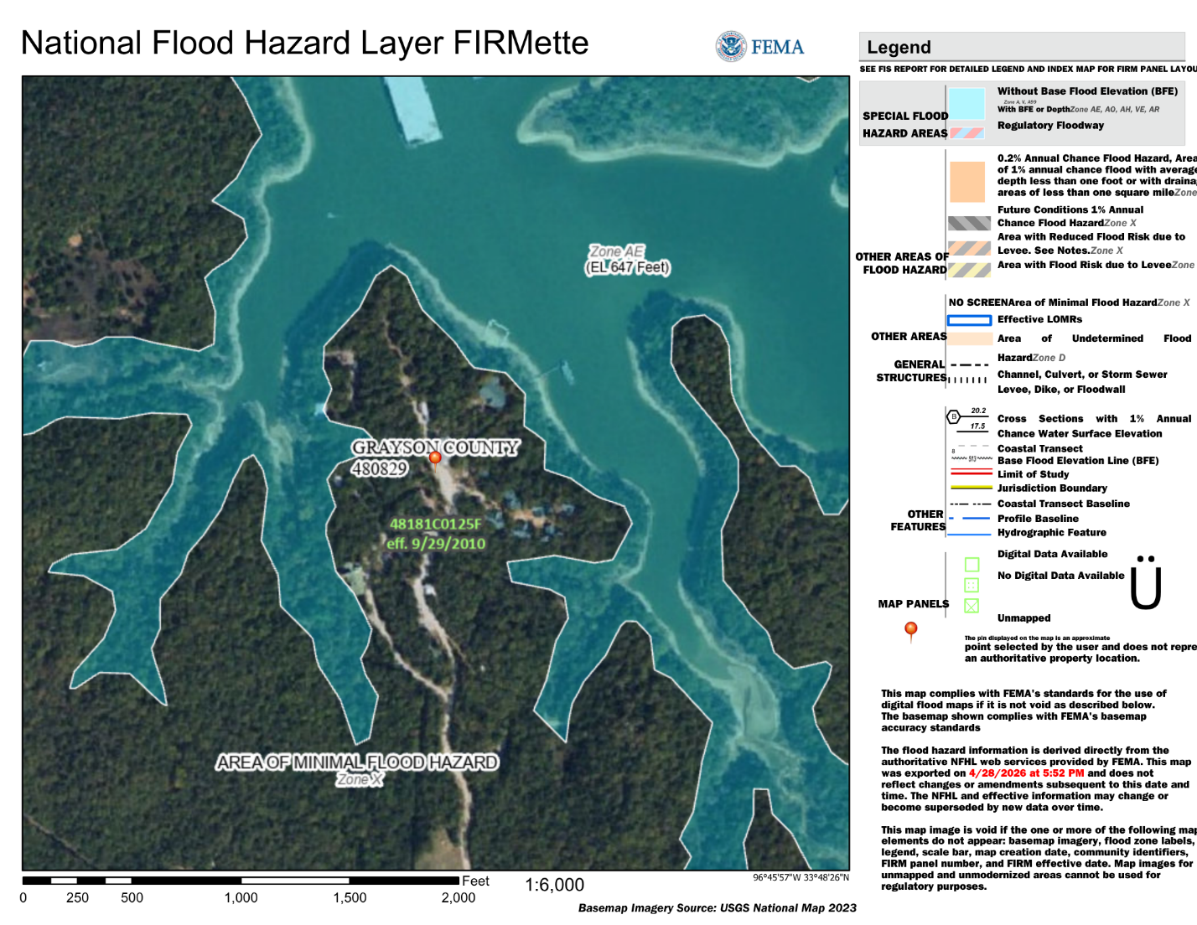

Also available at: https://msc.fema.gov/portal/search?AddressQuery=418%20Stanton%20Way%20Pottsboro%20texas
All parents or guardians of campers must sign a receipt of acknowledgement of the camp’s location relative to the floodplain. User group leaders will need to bring those signed receipts with them to TECOT where they will be filed and stored by the Camp Director. It will be the responsibility of the user group leader to collect the receipts from the parents/guardians and the responsibility of TECOT to store and maintain the receipts.

Appendix 1.ii
TECOT Base Camp Expansion
The map below shows the buildings and activity areas utilized by TECOT in the base camp area. Trails are defined in yellow. Muster, staff housing, and parking areas are also identified. The flood zone occurs from the rising level of Lake Texoma. There are no floodways or rivers located on the map. The entire flood zone for TECOT is due to the rising lake level of Lake Texoma, a process which takes weeks to months to accomplish. No youth cabins are located in the flood plain. No cabin ladders are needed for the youth cabins.
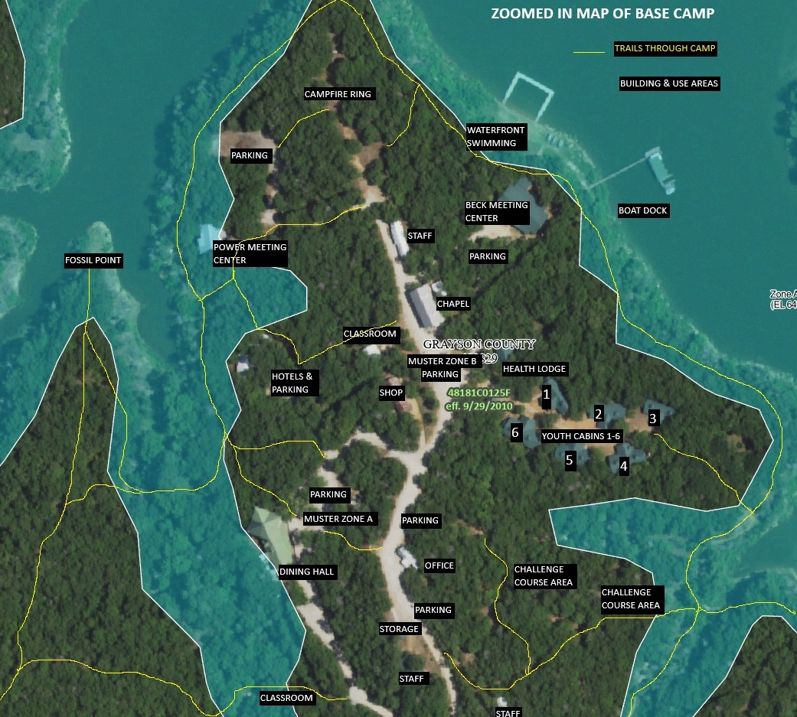
Appendix 1.iii
Map of Entire Property
Map of the entire TECOT camp boundaries (in red) and activity areas outside of the base camp area. Approximate trail locations are marked yellow. Note there are no floodways or rivers on the map. The entire flood zone for TECOT is due to the rising lake level of Lake Texoma, a process which takes weeks to months to accomplish.
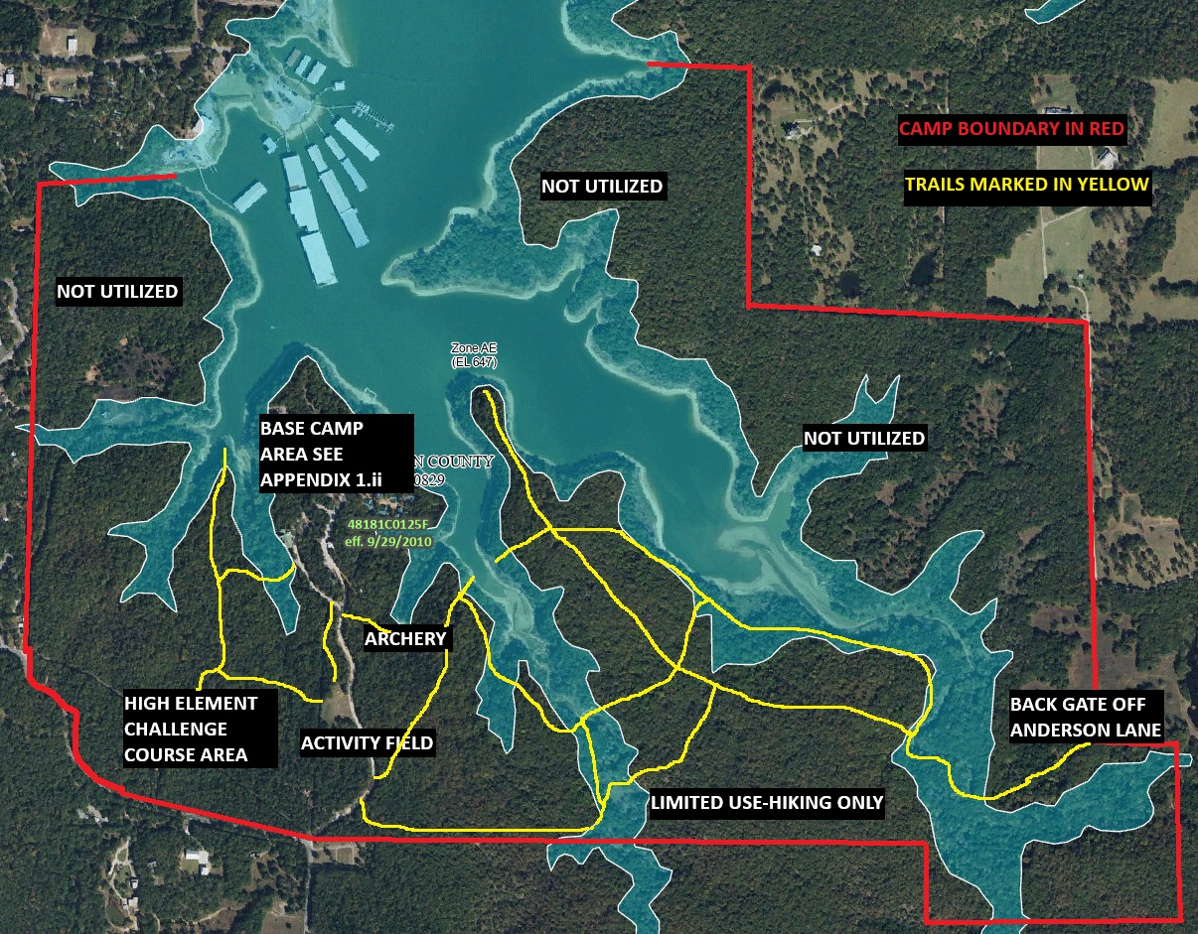

Appendix 1.iv
TECOT Muster Zone Map
Zone A-Primary Muster Point for Evacuation or Wildland Fire Safety
Zone B-Secondary Muster Point by Bell Tower
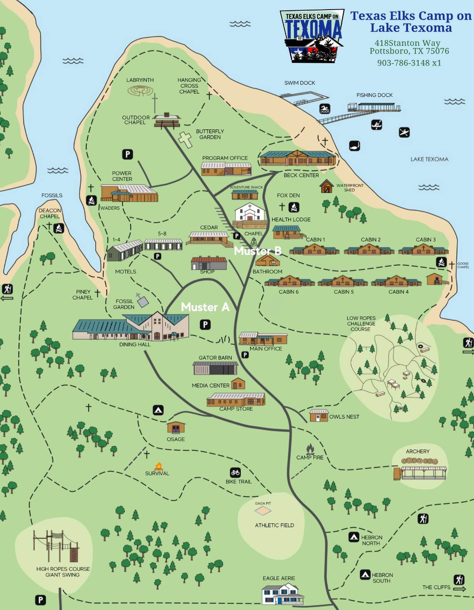
Appendix 2
Emergency Contacts

Emergency Numbers:
Emergency | 911
Sheriff’s Department |911 or 903.813.4408
Locust Fire Department | 911
Preston EMS | 911
Poison Center | 800.222.1222
Texoma Medical Center | 903.416.4000
Texoma Urgent Care Pottsboro | 903.786.3911
Family Pharmacy of Pottsboro | 903.786.2006
Grayson County Health Department | 903.893.0131
Grayson County Office of Emergency Management | 903.813.4217
Director’s Phone Numbers:
Sandi Creswell -- Executive Director | 903.267.3812
Steve Weatherly - President/CEO | 817.891.8100
Jake Carlson - On Call Staff/JOLT | 806.500.5062
Josh Velten- Emergency Preparedness Coordinator | 903.436.1462
Address:
Texas Elks Camp on Texoma
418 Stanton Way
Pottsboro, Texas 75076

Appendix 3
Acronyms and Abbreviations
ACA-American Camp Association
AED-Automated External Defibrillator
AC-Accountability Coordinator
CSO-Camp Safety Orientation
CC-Communication Coordinator
DSHS-Texas Department of State Health Services
EAP-Emergency Action Plan
EAS-Emergency Alert System
EMS-Emergency Medical System
ERC-Emergency Response Coordinator
ERF-Emergency Response Framework
ERT-Emergency Response Team
IC-Incident Coordinator
JOLT-Journey on Lake Texoma outdoor education program.
MC-Medical Coordinator
NOAA-National Oceanic and Atmospheric Administration
NWS-National Weather Service
OEM-Grayson County Office of Emergency Management
TECOT-Texas Elks Camp on Texoma
TC-Transportation Coordinator

Appendix 4.i
Evacuation and Muster Zones
Evacuation routes out of buildings are posted in each building, and routes to Muster Zones are illuminated by a combination of streetlights, building lights, and solar path lights. Muster Zones are defined at night by blue lights. UTVs and golf carts will be available to help those guests with handicaps or special needs.
User groups are responsible for providing all transportation for their group, including in the event of an evacuation while they are here. However, due to the potential emergent nature of an evacuation, in the event of a necessary emergent evacuation and sufficient transportation is not available, the IC will work directly with the Grayson County Sherriff Office and the Grayson County Office of Emergency Management to secure the transportation necessary. Initial contact will be through the 911 operator.
- Evacuations can occur for several reasons, including wildland fire, hazardous materials situations, and active shooter threats to the area. The decision to evacuate verses to Shelter in Place will be made by the IC.
  - Emergent Evacuation-Everyone-guests and staff-are to leave immediately due to an immediate threat. In this case, only emergent activities will be allowed, such as turning off kitchen appliances and looking for missing guests. Guests will be expected to check in with their user group leader for accountability, and then immediately leave.
    - Generally Emergent Evacuations should take 15 minutes or less.
    - Guests may need to leave belongings or property behind.
    - Staff may need to leave space “as is” to meet evacuation deadlines.
  - Controlled Evacuation-Everyone will eventually leave the property, but there is enough time for guests to gather their belongings before evacuating.
    - Generally Controlled Evacuations have a 2+ hour time frame.
    - Guests should be able to retrieve all property and belongings.
    - Staff will be able to secure all the buildings before departure.
- Once the decision is made to evacuate the camp, campers and guests will gather at one of 2 Muster Zones. Camp staff will announce which zone is to be utilized over the EAS. If the group is self-evacuating in vehicles already on site, the user group leader will gather with the group at the Chapel parking lot (Muster Zone B) at the Bell Tower for a head count and accountability check in partnership with the camp staff appointed Accountability Coordinator (AC). Once accountability of the group is confirmed, as their participants leave, the user group leader will continue coordinating with the camp EAP appointed AC and Transportation Coordinator (TC) who will coordinate any on-camp transportation needs to the muster point for special populations or guests having mobility issues.
- Groups being evacuated by awaiting buses or incoming vehicles will gather in Muster Zone A. Accountability will be taken by the AC and maintained as vehicles arrive for evacuation. Vehicles will use the loop in the road to efficiently and effectively evacuate guests. The Dining Hall may be used if an indoor space is necessary. Once the user group leader and AC confirm with the TC that all guests were present, accounted for, and loaded into a vehicle for evacuation, the evacuation may be considered over.
  - If all are not accounted for by the AC, begin evacuations for those that are, and begin the “Appendix 6: Missing Person” procedures for anyone missing. The important step is to know exactly who has been evacuated and who may be remaining at camp.
  - The user group leader, not the camp staff, is responsible for communication with camper families and decisions after leaving camp as far as where to relocate to and whether the group just leaves for home and cancels the remainder of the event. TECOT responsibility ends once guests are off the property. However, The IC may use knowledge of the local area to offer suggestions to the User Group Leader. The parking lot of the Brookshire’s grocery store in Pottsboro at FM120 and SH 289 (blinking light) is recommended as a staging point.
  - The IC shall be the last to leave the camp. If time allows, all doors should be checked and locked, and the front gate should be locked upon leaving, providing emergency vehicles will not need immediate access, such as in case of an approaching fire.
The IC will make sure all required paperwork is filled out and recorded with the appropriate agencies. The IC will lead a staff debrief as soon as possible to review the incident and look for ways to improve the epidemic plan in the future.

0000

Appendix 4.ii
Muster Zone A Evacuation Map
Designed for groups that will need buses or outside resources to evacuate if the evacuation order is given.
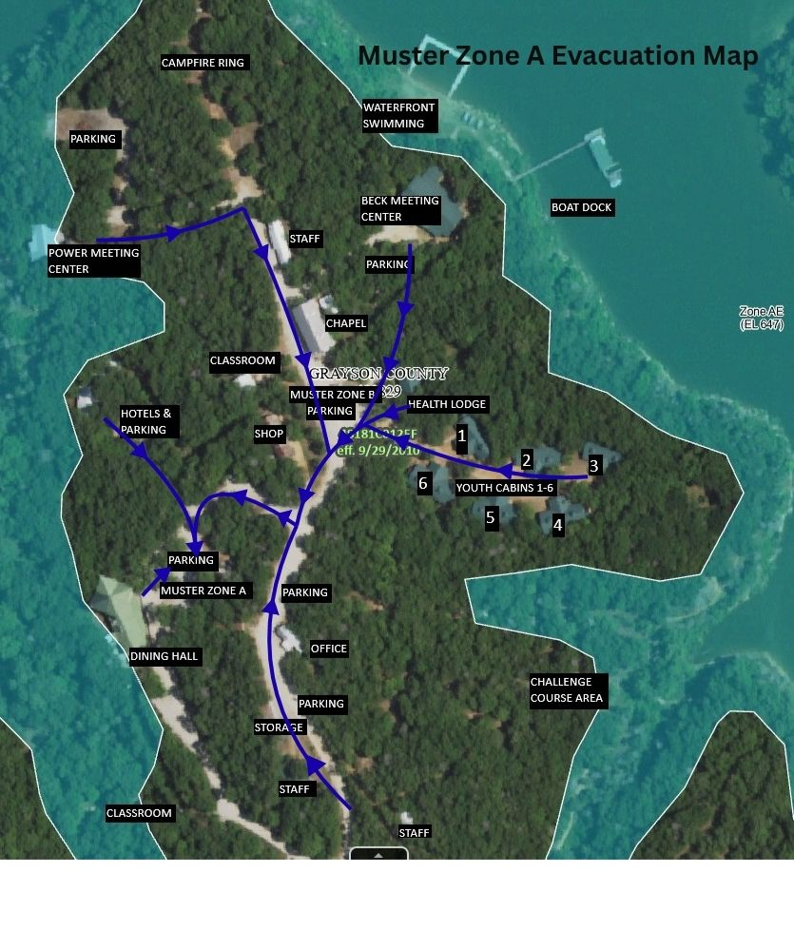
Appendix 4.iii
Muster Zone B Evacuation Map
Designed for user groups that will self-evacuate if an evacuation order is given.
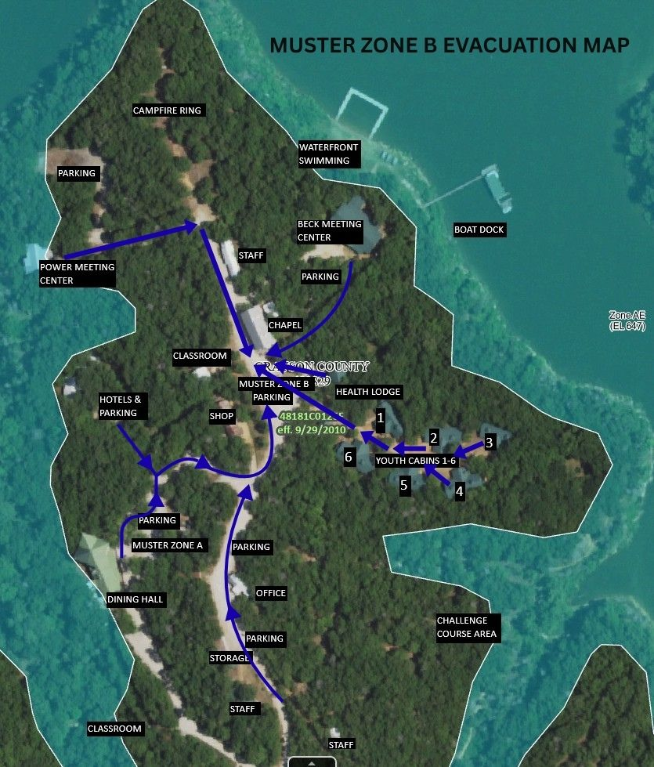
Appendix 5
Shelter in Place/Lockdown
Shelter in Place directives can occur for several reasons. Severe weather or strangers on camp are a couple examples of when sheltering in place will be necessary. The EAS will announce a Shelter in Place emergency and state the reason for sheltering. When tasked with sheltering in place, all guests and campers are to remain in the building they are currently in. If guests or campers are outside, they should immediately move inside the nearest building and close/lock the doors. No attempts may be made to run or get to another building once the order to Shelter in Place has been given.
If time permits, IC will designate a camp staff member to drive the base camp area of camp and ensure all guests are moved indoors and none are outside.
The IC will designate a camp appointed Accountability Coordinator (AC) to contact the user group leader via radio or cell phone and begin the accountability process of each building. Anytime a Shelter in Place directive ends, an accountability check should be immediately taken.
Shelter in Place directives for severe weather and tornadoes is covered in “Appendix 9 Severe Weather, Thunderstorms, and Tornadoes.”
A Lockdown is put in place if there is a security threat such as a wild animal, unknown person in camp deemed a threat, or an active shooter or other threat. A Lockdown directive means all campers and staff remain in their buildings with the doors locked or barred/blocked until an all clear is given.
Contact with camper’s guardians or parents will be the responsibility of the user group leader and not the camp staff. The user group leader will initiate and oversee contact with the camper’s guardians and parents and maintain contact and provide updates throughout the incident. TECOT may provide resources or staff to aid in the process if requested.

Appendix 6
Missing Person
User groups are responsible for tracking their own guests and campers. In the event a staff member is asked by the user group leader to help locate a missing guest:
- The initially contacted staff person will contact the Director or other camp leadership staff via radio to inform them of the missing person.
- Ensure the person is still on the camp. Some guests may leave in their vehicles, and cell reception prevents contact. Check to see if the vehicle is still on site.
- Check the bed assigned to the missing person and check with health staff or the school nurse (JOLT Group) to ensure the missing person has not gone to the Health Lodge.
- The camp bell may be used to guide missing guests back to base camp.
- The EAS can be used to broadcast the name of the missing person with instructions on where to check-in and be accounted for.
- At this point the IC will decide if activating the EAP is necessary and what resources to allocate from the camp or from outside sources (911). Description of missing person (name, age, description, and clothes) should be shared with all staff on site.
- All available camp staff will use knowledge of camp trails and activity areas to quickly do a search of the areas utilizing carts and UTVs. Dining Hall staff will check the Dining Hall and porches for missing people.
- Contact with missing person’s family will be the responsibility of the user group leader. The user group leader will initiate contact with the missing person’s family and maintain contact throughout the incident.
- If guest remains unlocated after 30 minutes:
  - Contact authorities to assist in the search efforts. Grayson County OEM will be contacted by 911 dispatch or first responders on site if pre-established criteria are met.
  - Keep uninvolved guests away from search efforts to prevent additional lost guests.
- Once located, IC will coordinate reunification with the group if necessary. All staff and other parties involved need to be notified immediately. Staff debrief will occur as soon as possible, and required documentation will be completed immediately.

Appendix 7
Fire Emergency
TECOT faces many sources of potential fires. Annual inspections and storage precautions eliminate many threats. The threat of wildland fires is also prevalent, especially during warmer or dryer times of the year. Guests should immediately contact the camp staff once they can do so safely if they see or smell smoke or fire. The initial staff member contacted by guests will radio all staff and alert them of the smoke or fire.
The Camp Director, or senior ranking staff member in charge will become the IC and will designate a staff member to call 911 if necessary to report the fire. Grayson County OEM will be contacted by 911 dispatch or first responders on site if pre-established criteria are met.
- If a fire is in a building, an assigned staff member will ensure all occupants are out of the building immediately, regardless of the fire’s size. Muster Zone B will be used for building fires.
- In case of a fire in the cabin circle, move campers to Muster Zone B, ring the bell continuously to alert guests to the emergency. All cabins need to be evacuated to allow for emergency traffic into the area. A staff member will be assigned the role of Accountability Coordinator for the duration of the fire. Accountability will then be taken to verify all guests and staff are accounted for. When the directive to gather at Muster Zone A is given, no one shall leave the Muster Zone until all clear is given by the IC. Staff with no designated assignment will gather at the muster zone to assist with guests and be available for assignments.
- If the fire is small and not spreading much beyond its starting point, a trained staff member may use a portable fire extinguisher to suppress the fire. Examples of small fires include fires on stove burners or in a trash can. (Note: If a fire is in a building, the Fire Department should be notified regardless of the size or scope of the fire.) Staff may make a single attempt to extinguish a fire in a building and then exit the building and not return.
- In the event there is a fire in the woods, stay calm and move into the wind, downhill, and away from the fire.
- In the event of a larger wildland fire on camp or moving toward camp, Muster Zone A will be used to gather all guests in preparation for a potential evacuation. A staff member will be assigned the role of Accountability Coordinator for the duration of the fire. Accountability will then be taken to verify all guests and staff are accounted for. When the directive to gather at Muster Zone A is given, no one shall leave the Muster Zone until all clear is given by the IC. Staff with no designated assignment will gather at the muster zone to assist with guests and be available for assignments as needed.
- Fire Department vehicles and personnel may be utilizing camp trails and roads, and all guests and staff need to remain clear of them.
- Contact with camper’s guardians or parents will be the responsibility of the user group leader and not the camp staff. The user group leader will initiate and oversee contact with the camper’s guardians and parents and maintain contact and provide updates throughout the incident. TECOT may provide resources or staff to aid in the process if requested.
The IC will make sure all required paperwork is filled out and recorded with the appropriate agencies. The IC will lead a staff debrief as soon as possible to review the incident and look for ways to improve the fire emergency plan in the future.

Appendix 8
Flooding Emergency
The flood threat at TECOT comes primarily through the rising of Lake Texoma. This is a gradual process that can be monitored over time (weeks and months). In the past, the rising lake eliminated activity areas, such as swimming and canoeing, but all buildings on the camp are located above established flood plains (see map on Appendix 1). The camp is not located in or near any established floodways, but there are 3 small creeks on the property that can grow in size (4-6 feet across) before running off into the lake. During times of heavy rain, the creeks are inspected by staff prior to crossing any footbridges and the creeks will be avoided if deemed unsafe (swiftly flowing water or debris laden water). TECOT activities are deliberately shifted indoors during periods of rain or severe weather in an effort to keep guests comfortable and avoid any dangers.
If there were to be a flash flood related event, or if the National Weather Service issues a Flash Flood Warning with an Evacuation Notice that included TECOT, all guests would be notified via the EAS to emergently gather at the Chapel at Muster Point B, which is the highest point in base camp. If evacuations are needed, Appendix 4 will be utilized to ensure evacuations are carried out in an organized and efficient manner.
Special considerations the IC will take for a Flash Flood Evacuation:
IC will designate a staff person to act as the Accountability Coordinator and speak with the user group leader and verify all guests and campers are accounted for. If the user group has the means to self-evacuate all their group, that information will be relayed to IC.
IC will designate a staff person to serve as the Communication Coordinator (CC) and contact 911 and alert the emergency response system to the evacuation need of TECOT. If the group is able to self-evacuate, that information will be relayed to the emergency dispatcher. The CC will ask the emergency dispatcher if all roads are open between TECOT and the City of Pottsboro. There are several areas prone to flash flooding on the highways into camp, and guests may be safer remaining on camp if the roads are already flooded.
If there is a need for outside resources to evacuate the group, that information will be relayed to the emergency dispatcher, and coordination will begin for evacuating the group. The CC needs to relay the location, number of people to evacuate, ages, and weather/flood conditions to the emergency dispatcher. The CC will request the emergency dispatch notify GCOEM and the CC will be the primary point of contact with GCOEM relating all information to the IC who will relay information as necessary to the staff and user group leader.
Appendix 9
Severe Weather, Thunderstorms, and Tornadoes
Potential severe weather conditions that may impact TECOT include severe thunderstorms that could cause strong winds, hail, lightning, or tornadoes. TECOT staff monitor the weather continually and will relay severe weather information to guests as it is updated and available. The camp EAS will announce what weather emergency is occurring and the proper actions to take.
- In the event of severe thunderstorms causing lightning, strong winds, hail, or tornadoes, everyone will move indoors until the storm passes. All available camp staff will ensure this has occurred and remain indoors as well.
- If the storm becomes more serious with the threat of a tornado (tornado warning), all individuals are to move to shelters:
  - Cabins: counselors’ restroom and restroom
  - Beck: restrooms
  - Powers Center: storage closet or Women’s restroom
  - Dining Hall: dry storage pantry and office, with overflow in women’s restroom
  - Public Restroom
There will be floor plans and signs in each space designating tornado shelters and building evacuation routes. All available camp staff will ensure groups have moved to designated shelters and seek shelter themselves.
- Staff on duty will keep watch on weather through weather channel/radio utilizing the National Weather Service (NWS). The NWS is programmed on channel 4 of every hand-held radio. Office staff will monitor the NOAA Weather Radio for alerts, watches, and warnings.
- IC will appoint a camp staff member as the Accountability Coordinator (AC). The AC will work with the user group leader via radio or cell phone and begin working on accountability for all sheltered guests and campers on camp.
If a tornado moves through the site, the priority after it has moved off is accountability of all campers and staff. The IC will decide, based on a rapid assessment of the accountability report taken by the camp staff appointed Accountability Coordinator (AC), potential injuries, and physical damage to the property, what external resources to bring into the camp for recovery efforts.
The IC will appoint a staff member to call 911 with as much information as possible. Grayson County OEM will be contacted by 911 dispatch or first responders on site if pre-established criteria are met.
Until arrival of those resources and first responders, campers and staff will move to a Muster Zone (may need to establish a temporary one) or remain in unimpacted buildings. Appendix 10 covering severe accidents or injuries will be utilized if there are injuries following a tornado.
Contact with camper’s guardians or parents will be the responsibility of the user group leader and not the camp staff. The user group leader will initiate and oversee contact with the camper’s guardians and parents and maintain contact and provide updates throughout the incident. TECOT may provide resources or staff to aid in the process if requested.
If a tornado moved through TECOT with no injuries, IC will ensure a call will be placed to 911 to verify with 911 that the camp has no injuries and needs no medical resources.
After accountability is confirmed and injuries addressed, a more in-depth site survey will take place to look for physical damage to building and infrastructure, road blockages, or other hazards that may have appeared during the event. Campers will shelter in place until the damage assessment is complete and campers can safely move through camp.
Following the incident, the IC will ensure all required documentation is completed and submitted to the proper agencies. A staff debriefing should occur as soon as possible and include ideas on ways the EAP can be improved for the next response.

Appendix 10
Severe Injury, Accident, Illness, or Death Procedures
At camp people can get sick or injured from multiple potential sources. Since all staff must be certified in basic First Aid/CPR/AED, when one of these events takes place, staff will revert to that training. All groups are responsible for their own medical supervision and emergencies and are encouraged to have medically trained personnel on site during their stay at camp. But staff can step in during instances where group leadership is absent, at the group’s request, or during any emergency when staff level of training exceeds those of the group.
- In the event of an incident involving an illness or injury consider “Call First” or “Care First”
- Staff members on scene can provide care as needed to their level of training. Call the Camp Director or senior ranking staff member on the radio and report the incident. At that point, IC is established and the EAP will become active.
- The IC will appoint a staff member to call 911 with as much information as possible. Grayson County OEM will be contacted by 911 dispatch or first responders on site if pre-established criteria are met.
- IC will verify EMS was called (If needed), verify the user group leader is aware, and coordinate additional staff support of the incident.
- Staff may perform First-Aid if appropriate; stay with the individual until someone with a higher level of training or authority arrives. Do not leave the scene unless safety is an issue. In the case of a death, every effort will be made to secure the scene and preserve any evidence until the arrival of first responders.
- Uninvolved campers need to be escorted out of the area by designated camp staff.
- IC will assign a staff member as Transportation Coordinator who will staff the UTV(s) designated for emergency response and assist moving EMS personnel and other first responders and equipment to the patient or bringing the patient to the ambulance.
- Contact with the injured or deceased individual’s family is the responsibility of the user group leader and not the camp staff.
If an ambulance is called to camp:
Notify staff on call or Camp Director immediately. The need for EMS on site will automatically activate the EAP. The local fire department responds with EMS so there will be several emergency vehicles arriving on camp. Grayson County OEM will be contacted by 911 dispatch or first responders on site if pre-established criteria are met.
Place staff member at the gate, the office, and close to the medical incident to provide directions to emergency responders.
All media inquiries about the incident will be referred to the IC. The IC, or their designee, will be the only person to speak and represent TECOT. The IC will ensure any follow-up with additional agencies on behalf of TECOT occurs.
Immediately after the incident the IC will ensure all required paperwork is completed. Staff debrief will occur as soon as possible and include analysis of what could have been improved and how EAP could be adapted in the future.

Appendix 11
Epidemic Plan
The Epidemic Plan is a DSHS requirement that will be enacted anytime there is a potential epidemic outbreak. The plan will have three possible sources of implementation.
•When multiple staff or campers display similar symptoms simultaneously. These symptoms include fever, vomiting, rash, diarrhea, cough, sore throat, flu-like sickness, etc).
•A contagious illness is suspected or confirmed by medical providers or healthcare staff.
•Notification is received from the group leader that a parent, guardian, or public health authority regarding potential exposure of a camper prior to their stay at camp.
The IC will coordinate with all relevant outside sources to ensure steps are taken to prevent the spread of any possible epidemic or communicable disease. The Grayson County Health Department’s office should be the first contact made after a possible outbreak is suspected. The guidance offered by this office will guide TECOT’s initial actions beyond the EAP.
Once symptomatic individuals are identified, move affected campers or staff to designated isolation areas. This area is defined based on the number of individuals identified. It could be the health lodge, an empty cabin, or empty motel rooms. Appropriate Personal Protective Equipment (PPE) such as gloves and masks will be used by staff when interacting with identified individuals. Individuals should be checked regularly, and conditions logged such as initial time of onset, observed symptoms, date/time, and severity.
Deliberate efforts will be made to limit all contact with uninfected campers and staff.
IC will coordinate with the user group leader to ensure all necessary communication takes place with identified individuals and their families. Communication with families will be the responsibility of the user group leader and not the camp staff. The camp staff IC will be the point of contact for any county, state, or federal agencies that may have interest or oversite of the potential outbreak and for reporting and updating any contagious disease.
A medical officer (MO) from camp staff will be assigned to track, record, and coordinate all logged conditions of individuals and compile a list including the number of identified individuals, ongoing symptoms, times, and outcomes. This data will be reported to the health department by IC as needed or requested.
Disinfection and prevention efforts will be stepped up by all campers and staff. Personal hygiene practices such as frequent washing hands and not sharing personal items will be implemented. All areas identified individuals used or stayed in will be thoroughly cleaned and disinfected by staff. Personal items of identified individuals will be collected and stored in an isolated area. TECOT will increase the frequency of cleaning and sanitizing the camp.
Activities will be modified to ensure there is no chance of contamination or shared spaces with identified individuals.
All campers and staff will be monitored to ensure any infection is controlled. If new individuals continue to become symptomatic, efforts of isolation and disinfection will be escalated. Staff may be reassigned as needed to cover ill or quarantined staff. The IC will continue to regularly contact and seek guidance from public health authorities until the exposures have ended and the outbreak is over.
Post-Outbreak the IC will ensure the camp is thoroughly cleaned and prepared for use with all known possible contaminated areas or avenues of contamination are eliminated. The IC will make sure all required paperwork is filled out and recorded with the appropriate agencies. The IC will lead a staff debrief as soon as possible to review the incident and look for ways to improve the epidemic plan in the future.

Appendix 12
Aquatic Emergency Procedures
Prevention is a priority for TECOT when addressing potential aquatic emergencies. The waterfront and aquatic activities are only permitted under adult supervision, and all swimming requires lifeguards trained in open water (with certifications verified and on file). All state ratios for lifeguards will always be used. Life jackets are always available to all guests, and state law requires all boat and vessel occupants 16 years old and under always wear a life jacket. Camp rules require all users of camp owned canoes and kayaks to wear life jackets when on the water, and it is recommended to groups to have lifeguards available for non-swimming waterfront activities. Swimming will not be permitted when lightning occurs within 20 miles of the waterfront based on credible lightening safety apps.
In instances of aquatic injury, drowning, or near drowning, lifeguards are expected to perform their duties as trained. Response by TECOT staff will supplement the lifeguard’s response and possible resuscitation efforts and the Appendix 10 protocol for severe injury or medical emergencies will be enacted if care beyond the camp level is needed.
The first staff member notified or aware of the incident will immediately call the Camp Director or senior staff member and inform them of the incident. The IC will appoint a staff member to call 911 with as much information as possible. Grayson County OEM will be contacted by 911 dispatch or first responders on site if pre-established criteria are met.
Communication with the camper’s parents or guardians will be the responsibility of the user group leader and not the camp staff.
In the event the aquatic emergency involves boaters or swimmers needing retrieval, TECOT may use one of its pontoon boats to retrieve the affected campers or staff. IC will designate 2 staff members to retrieve the errant campers or staff and their watercraft.
Post incident, the IC will make sure all required paperwork is filled out and recorded with the appropriate agencies. The IC will lead a staff debrief as soon as possible to review the incident and look for ways to improve the aquatic emergencies plan in the future.

Appendix 13
Stranger or Unauthorized Person on Camp
Security breaches can occur numerous ways at TECOT. Unknown visitors may walk, hike, drive, or boat into the property. All visitors are required to check into the office and have passes, including vendors for delivery and contract work.
- If an unknown visitor is spotted, radios should be used to alert multiple staff to the situation. The visitor should be contacted in a friendly manner to inquire about their presence and purpose on TECOT.
- Visitors with a purpose should be directed to the office to register and get a badge. Radio/call the office to advise them a visitor is going to stop there to register. Once the visitor has a badge, office staff will announce over the radio that there is an authorized, badged visitor onsite.
- If a visitor is unruly or argumentative, ask them to leave the property. If they refuse, disengage them and call on the radio for the supervisor on duty and make them aware of the situation.
  - The supervisor on duty may then approach the subject again or may call 911 to report the trespasser. With youth on camp, it is important that all visitors be verified, and the user group leader should be contacted about any unscheduled visitors claiming to be a part of the user group BEFORE directing the visitor to the group location.
  - The shelter in place or lock-down procedures from Appendix 5 may be enacted at this point if necessary for the safety of the campers and staff.
- In the event the Grayson County Sherriff’s Office is contacted, the unwanted visitor should be monitored (from a distance if necessary), and user groups should avoid the area and/or contact with the visitor.
- Once an unruly visitor has been removed from the property, an all-clear will be sounded.

Appendix 14
Active Shooter
Unfortunately, Active Shooter situations have spread to all areas of society, including camp settings. An active shooter on site is an extremely important event that must be handled immediately and swiftly.
The camp is located in a rural setting, and it is common to hear gunfire from local ranges and residents at times throughout the day, usually sounding “off in the distance.” If there is any doubt as to the nature of gunfire, err on the side of calling 911.
After consulting with the Grayson County Sherriff’s Office, TECOT adopted the “Run, Hide, Fight” strategy for active shooter situations. Guests and staff will first run to avoid the situation all together. If that is not possible, hiding from the active shooter is the next best choice. If confrontation is inevitable, guests and staff will fight by any means necessary.
- The first staff aware will immediately announce the active shooter on the radio. IC will immediately ensure 911 has been called and activate the EAS in the buildings and advise all campers and staff to lock down in buildings. If there is any doubt 911 has been called, call again. If there are further details of the situation-exact location of the shooter(s) or injuries, for example, call 911 again to advise the dispatcher of the changes.
- All guests and staff should run and hide as far as possible from the area. Radio traffic can be used simply to state staff and however many guests are safe. Do not give locations over the radio because the shooter(s) may have access to one. Stay hidden until all clear is sounded. This will be done via radio or law enforcement megaphone/speaker. Ringing the bell will not be used in the case of an active shooter.
- If unable to run, find a spot to hide and await news of an all clear or for the arrival of law enforcement to escort campers and staff to safety. Radio traffic can be used simply to state staff and however many guests are safe. Do not give locations over the radio because the shooter(s) may have access to one.
- If it is safe to do so, updates will be given over the EAS to keep campers and staff informed of the status of the incident.
- If cornered by the shooter, engage the shooter by whatever means necessary at your disposal.
- Once the situation is mitigated, all staff will work to account for guests and begin addressing missing guests and administering first aid as needed. Following an active shooter situation, the Dining Hall and Muster Zone A will be the gathering point for any injured guests or staff. All first aid kits and supplies from the health lodge may need to be moved to the Dining Hall.
- More than likely there will be an abundance of emergency response resources on site by time the active shooter threat is eliminated. If not, enacting Appendix 10 for medical emergencies will be enacted to begin treating injuries and beginning the accountability process.
- Post incident, the IC will ensure all required paperwork is completed and submitted to the appropriate agencies. A staff debrief needs to be completed as soon as possible and include in the discussion ways the EAP can be improved for this event.

Appendix 15
Animal Encounters
The natural environment of TECOT results in daily animal encounters. Separating campers from potentially harmful encounters is a priority for the staff and many times that is done behind the scenes, such as relocating venomous snakes away from base camp or spraying wasp nests in living areas. Occasionally there may be animal encounters that require the activation of the EAP.
Dangerous animals at TECOT include venomous snakes and spiders, stray dogs, wild hogs, large cats, and any animal potentially carrying rabies. All animals are wild and should be treated as such. Even something as minor as a bee sting could be deadly to a person with an allergy. If a threatening animal is spotted on camp, it must be reported immediately to staff and not approached. Once contacted, staff will call in on the radio and staff will investigate the animal sighting.
If there is a verified threat that cannot be quickly and easily mitigated, the staff will call the IC to activate the EAP. The IC will evaluate the need to bring in outside resources such as animal control or game wardens.
The IC will oversee potential schedule changes and schedule adjustments to keep the animal(s) separated from campers. If necessary, Appendix 5, Shelter in Place may be activated until the animal threat is over.

Appendix 16
Transportation Emergencies
TECOT does not provide transport to campers, nor does it utilize third parties for any transportation of campers. Procedures related to transporting campers do not apply to TECOT.
TECOT does not maintain any corporate owned vehicles. In the event a staff member experiences a transportation emergency in their personal vehicle while performing authorized camp related activities (attending events, running errands, etc), the staff member will immediately inform the camp director or CEO of the emergency after calling 911 (if necessary). The camp director or CEO will gather all necessary information and provide immediate resources as needed on behalf of TECOT. If practical they may respond to the location and assist on scene. The camp director will be responsible for filing claims and any follow-up with insurance providers or legal representatives.
TECOT visitors and guests that drive through camp that experience a transportation accident will be treated on a case-by-case basis. Contact with involved camper’s guardians or parents will be the responsibility of the user group leader and not the camp staff. The user group leader will initiate and oversee contact with the camper’s guardians and parents and maintain contact and provide updates throughout the incident. TECOT may provide resources or staff to aid in the process if requested. TECOT will communicate with any agencies requiring site specific actions or information.
Transportation incidents that do not cause any injury or damage to TECOT property will be the responsibility of the individual involved to report.
Transportation incidents that do not cause any injury, but damage TECOT property will be reported by TECOT. The first staff person to become aware of the incident or damage will immediately call the Camp Director on the radio. The Camp Director will follow up with the party involved and exchange information. If a police report is needed, the non-emergency number for the Grayson County Sherriff’s Office will be called to report the accident.
Transportation incidents that cause injury to any individuals will be called and reported to 911. The first staff person to become aware of the incident will immediately call the Camp Director on the radio. The Camp Director will assign a staff person to call 911 and report the incident with as many details as possible. The EAP will be activated and “Appendix 10: Severe Injury, Accident, Illness, or Death Procedures” will outline response to the emergency. Grayson County OEM will be contacted by 911 dispatch or first responders on site if pre-established criteria are met.
Transportation, with or without injury, that result in the release or potential release of hazardous materials will be reported immediately by TECOT. The first staff person to become aware of the incident will immediately call the Camp Director on the radio. The Camp Director will assign a staff person to call 911 and report the incident with as many details as possible. The EAP will be activated and “Appendix 10: Severe Injury, Accident, Illness, or Death Procedures” will outline response to the emergency. Appendices 4 and 5 governing evacuation and shelter in place procedures may be enacted based on hazardous materials release or potential release. Grayson County OEM will be contacted by 911 dispatch or first responders on site if pre-established criteria are met. Once on scene, First Responders will guide TECOT’s decisions on when and if to enact additional EAP Appendices and the time frame for issuing an all clear and deactivating the EAP.

